CISC7204 Data Science and Data Visualization
Class E-Team 01-individual profile picture

- MC654992 SONG ZHUOXI
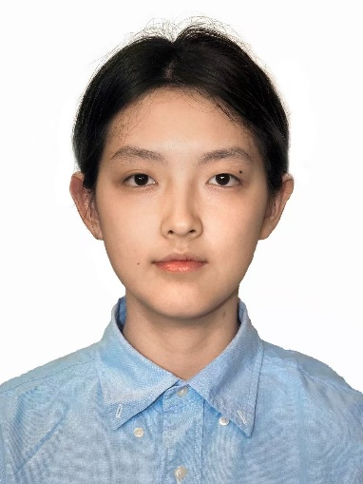
- MC642969 XIAN QILAN
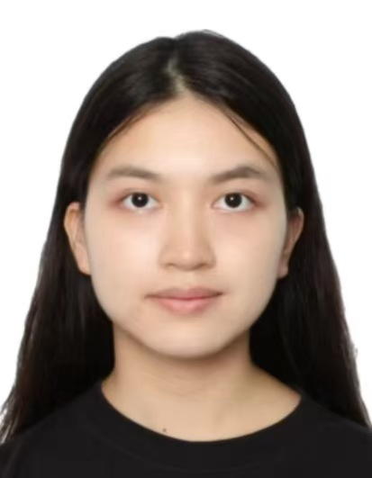

- MC654953 FONG HIO LAM


- MC653748 FONG CHIN WAI


- MC653235 KUAN CHI KIT


- MC652817 KONG KIN MENG


